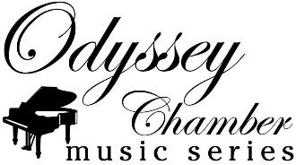
Advertising Reservation Form

Your information:
Name: Title:
Business:
Mailing Address:
Email: Phone: ( ) -

- Unless requested, you will be recognized as our Sponsor by your business.
- You would like to be recognized instead, as
- Check here, if you would prefer NOT to be recognized as Sponsor.

Reserve the following dates:

# | Concert Date | Type (Livestream or Print Program) | Size | BW or Color? | Cost
1
2
3
4
5
6
7
8
 |  |  |  | TOTAL: | $

Payment Options:
- Check is preferred; payable to “Odyssey”
- Credit Card via Paypal: Send funds to OdysseyColumbia@aol.com . Please memo “Advertisement.” Please add 3% transaction fee.

Complete the Reservation Form, then e-mail or mail to:

Ayako Tsuruta
info@Odyssey Missouri.org

Odyssey - c/o First Baptist Church
1112 E Broadway, Columbia, MO 65201

